Introduction
This document provides an explanation for various implementation aspects

Problems statement
With connecting more devices to the Internet, It become more threatened by cyber-attacks, which brought great opportunity as well as great challenges, indeed security is on the top of those challenges with 1) more than XXX malware created each XXX, 2) the growing importance of digital data and 3) the development of complex tools to harvest them, the normal users became considerable targets whom can be easily hacked which put huge significance for security and safety.

Facing these new challenges need developing new techniques that take into consideration not only efficiency but cost, size, speed and portability requirements that vary from one application to another.

In this work we suggest using DAD (Deep anomaly detection) methods as 1) traditional algorithms fail to capture complex structures, 2) Need for large scale anomaly detection to make use of the huge amount of available data, 3) Deep anomaly detection eliminate the need of manual development features by domain expert, 4)boundary between normal and anomalous data is not precisely defined by domain experts

Related work
Deep anomaly detection models could be classified into three categories according to availability of data: 1) Supervised learning 2) Semi-supervised learning 3) Unsupervised learning
Supervised Learning: binary or multi-label classifier trained using labels of both normal and anomalous data, its drawback is the need of labeled data and disability to deal with new unknown attacks.

Unsupervised learning: techniques detect outliers solely based on intrinsic properties of the data instances. Unsupervised DAD techniques are used in automatic labeling of unlabeled data samples since labeled data is very hard to obtain, its drawback is that these models assume a high prevalence of normal instances than abnormal data instances failing which would result in high false. positive rate.
Semi-supervised Learning: instead of training the model to classify anomalies, the model is trained to understand normal cases, so that it can differentiate between normal and anomalous behavior, the advantage of this is the ease of producing normal labeled data.

Our contribution

We search for a method that could 1)harvest huge amount of data, 2) deal with new anomalies, 3) small size, 4) portable, 5) understand data as an instance and contextually
We suggest usage of semi-supervised learning with auto-encoders accompanied with attention mechanisms to help the model deal with long instances.

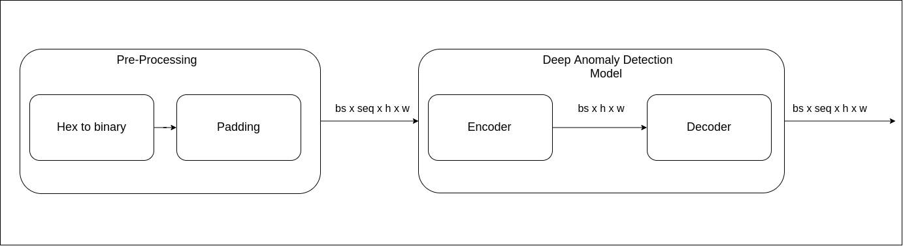

Figure X shows our general designed
Pr-processing phase is responsible for 1) converting the input from hexadecimal representation to binary one, this will be a key to facilitate dealing with some kinds of attack as we will show in the following sections, it facilitates the reconstruction objectives of the model by shrinking the possible outputs from 16 to just 2 labels. 2) Padding the input to definite shape so inputs of various sizes could be dealt with easily, CNN or LSTM layers could easily be stacked to analyze the sequence of data due to equal length representation provided by the unit.

Encoder
We Use Convolution 2D layer which proved to meet the required objectives, note that the quality of reconstruction is not the goal itself but the difference in quality of construction between normal and anomaly is what matters.
The Convolution layer is used so that it compress the input and creates a time relation between frames.
The input channel are the sequence length of the input and outputs single channel, It has with stride of 1x1 since we don’t want to change the shape of frames we only aim to create the time relation between frames.

Another Candidate
Another promising candidate is Einstein sum.
This function provides a way of computing multi-linear expressions (i.e. sums of products) using the Einstein summation convention.
it is also used to create time relation between different input frames so that contextual analysis occurs in our model.
The input sequence is the first input to Einstein sum while the second is trainable tensor of the same shape of single frame input, the output is as shown in figure XX a compressed representation of each sequence times the batch size.

Decoder
We used Convolution transpose 3D to exploit its ability to create an extra dimension in its input, in our case it will reconstruct the input from the compressed representation.

Complex designs were tested and we found this simple set up is enough to achieve the requirements.
In the following section we show the equal behavior of complex vs. simple models.

Complex Designs
U-Net
We used the same general architecture in figure 1.a but with replacing the encoder and decoder layers with UNET Architecture, the key reasons for this was: 1)Unet naturally has the structure of autoencoder 2)Modularity of the architecture which allow stretching or shrinking the encoding or decoding path as needed without mucg\h change 3)Transfer learning (usage of pre-trained models and fine tuning) 4)Unet has extra signals sent from encoder to decoder which we call Helping Signals which enhance the reconstruction quality 4)Helping signals could be cut or connecter as required 5)Helping signals allows increasing compression level. 6)Provides constant length representation for input.

U-Net with Einstein sum
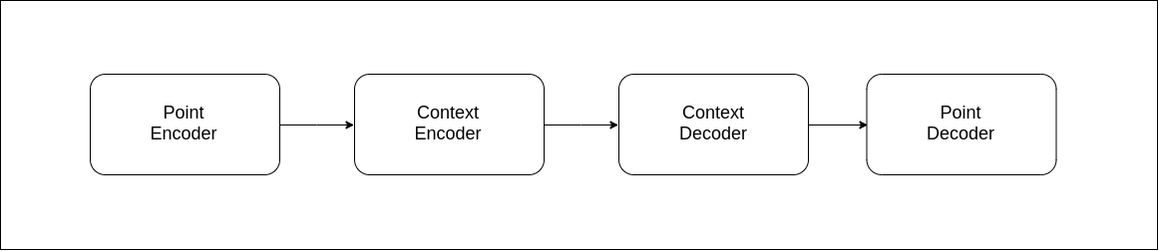

Figure 1.b shows the general set up suggested in this experiment
Our intuition in this design was that a two level analysis is needed to detect an anomaly: 1) point analysis 2)Sequence analysis.
For point analysis we used U-Net encoder for the same reasons mentioned in the last section.
For the sequence analysis we used Einstein sum.
For Context decoder we experimented two different components: 1)Transformer Decoder 2)Convolution Transpose 3D
For the last layer U-Net decoder is used.

In the following section we will show results for various shows set ups.

Results
We evaluate our designs on fuzz attack datasets that simulate an Ethernet attack on a moving car, The dataset could be divided into four different phases : 1) Normal 2)attack where the car starts to receive frames with very high rate 3)Disable where the host (node which receives frames) in no more able to sustain this rate of input so it halts 4) End of attack where received frame rate return to its normal rate.

We use Adam optimizer with learning rate 0.001, batch size equals to 8 and 20 frames long for each sequence where the image is padded to 112 (height) x 112 (width).
Each experiment is run for 6 epochs on a training set of 368 batches (58880) and evaluated on 92 batches (14720 frames).Experiments are conducted on i5-8400 CPU 2.80GHz × 6 with graphics GeForce GTX 1070 and 16 GB RAM.

The dimension of the padding is determined to: 1) Contain all possible frame lengths and 2) Create images of large size enough to use U-Net architecture
Note that with varying sequence length the model achieves the same distribution for different parts of the dataset.
Note that these results are obtained using batch evaluation(batch of sequences), with increasing the batch size the model is able to separate different groups better, while with small batch size overlapping between normal / attack and end occurs, this fits our application since usually there are a continuous flow of input.

Model Name | Normal separation | Attack/Disable Separation | End separation | Evaluation Time sec | Model Size (MB)
U-Net + Einstein sum + transformer decoder | 1 | 0.95 | 1 | 17.2 s | 223.2
U-Net + Einstein sum + Conv Transpose 3d | 1 | 0.95 | 1 | 16.4 s | 33.3
U-Net | 1 | 0.95 | 1 | 16.3 s | 31.3
Convolutional Encoder | 1 | 0.95 | 1 | 1.66 s | 1.2 KB
Einstein sum | 1 | 0.95 | 1 | 2.01 | 51.2 KB
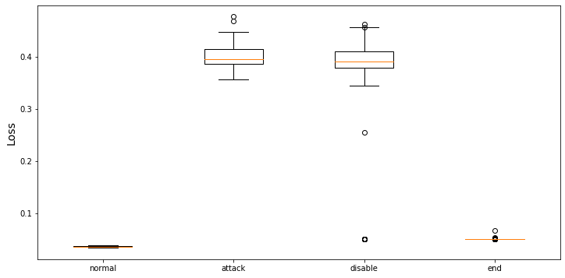
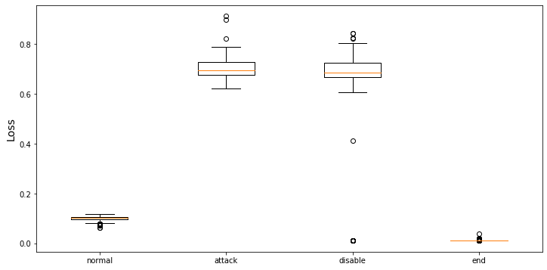
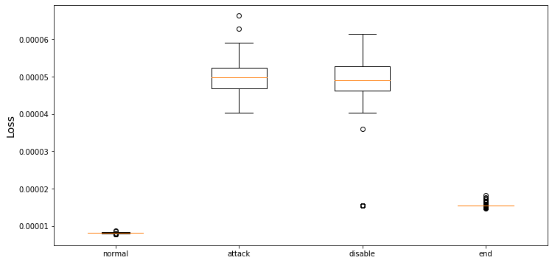
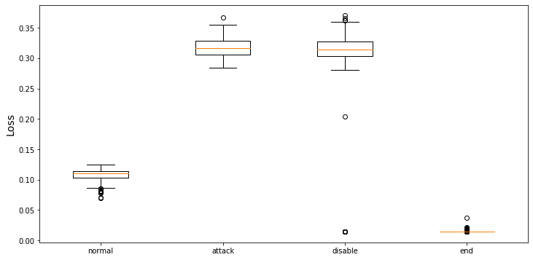
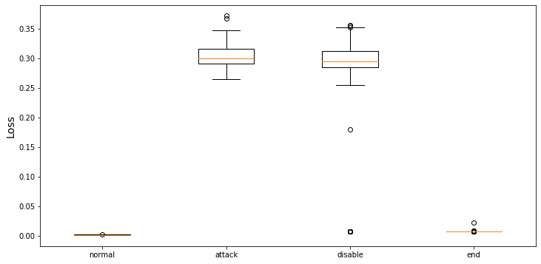
Figure Shows the loss obtained from each part of dataset: U-Net + einsum + transformer decoder , U-Net + Einstein sum + Conv Transpose 3d ,U-Net ,Convolution encode, Einstein sum

The superiority of Einstein sum encoder and Convolution encoder models is obvious in terms of separation quality, speed and model size on disk we consider this success is due to the conversion from hex to binary which facilitated the problem by classifying only to classes 0 or 1, and helped the model to easily detect any kind of frames that have different 0 to 1 ratio.

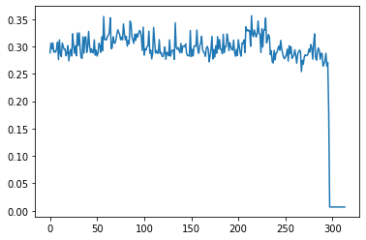
In some Images it may appear that the end part and the normal part are in separable, This is due to the large difference between normal & end on one hand and attack & disable on the other hand.

The image to the right shows a relation between batch number on x-axis (could be interpreted as time) and reconstruction loss on y-axis. Data obtained from evaluating disable phase.
We noticed a repeated pattern in the disable phase which occur with all models , this sudden drop in loss represent the overlap which occurs with the end dataset resulting in slight drop in separation accuracy, however this drop occurs in the transition phase between anomaly data and the end of attack which considered in this position an accepted behavior.
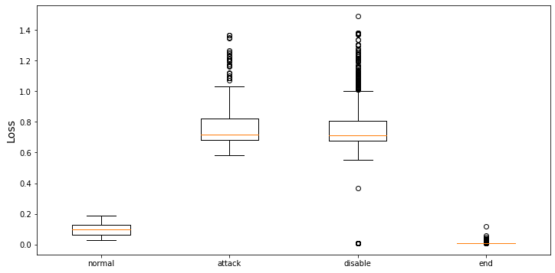
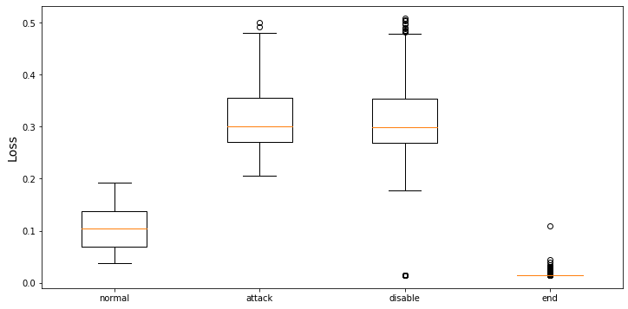
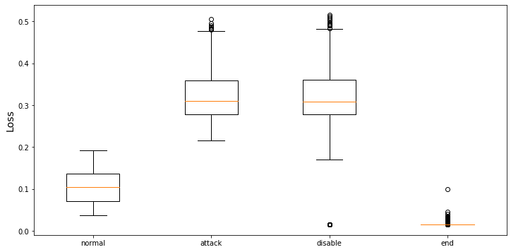
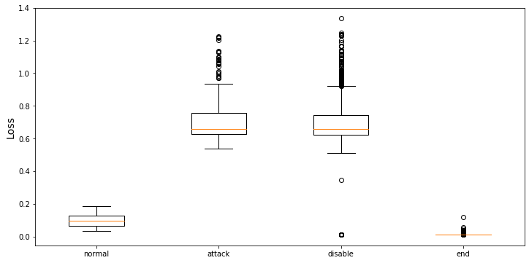
Figure shows the evaluation on batch size of 2 instead of 8, convolution without training,convolution with training,Einstein without training,Einstein with training,

Ablation study
In this section we do experiments to discover abilities of Einstein sum and Convolution Encoder layer since both have a similar behavior.
We put both models under the test of decreasing the batch size which will lead to fewer data input to the model, this often lead to overlapping between classes (normal / attack /disable / end) since the model review a shorter part of the data.

Model Name | Without training |  |  | With training
 | Normal separation | Attack/Disable Separation | End separation | Normal separation | Attack/Disable Separation | End separation
Convolutional Encoder | 1 | 0.941 | 0.999 | 1 | 0.991 | 0.999
Einstein sum | 1 | 0.943 | 0.9964 | 1 | 0.943 | 0.9960

Both models proved to be stable with the change of batch size, slight decrease occur with both models and about no change occurred with training which shows another aspect of the models that those models could not achieve more than this level of separation and when used with complex problems it’s better to stack them with deeper architecture.
Despite the high separation level, higher speed and smaller size on disk achieved by Convolution Encoder, Einstein sum provides a larger separation margin between Normal and attack phases.

LKA Dataset
Description
Targets the lka unit (lane keeper assistant) which is the component responsible to keep the car in its lane as long as the lka is enabled, it could be disabled by the user to switch the lane.
Note that disabling the LKA is not an anomaly but disabling the lka while switching the lanes is a probable anomaly, which suggests an unauthorized disabling occured by a cyber attack.
The lka in this dataset is considered an anomaly since it occurs during the lane switch by the car, which normally should occur before the driver starts to switch lanes.
Our main frames that describe these features:
VIS: frame responsible for updating the system with the distances between left and right road lines.
LKA: which is responsible for updating the system with LKA state
Architecture
The type of anomaly in this dataset is different since it doesn’t depend on a long sequence of anomalous input but instead it’s a single frame that is considered an anomaly only in this specific context.
Our traditional models were unable to detect such problem, So we suggest this new architecture to face this problem, which gives extra attention to both VIS and LKA to create a relation between both frames.

We suggest 2 predictive models which in general takes input of time (t-1) and predict that of t.
The first predicts VIS (VIS predictor) and the second predicts LKA(LKA predictor).
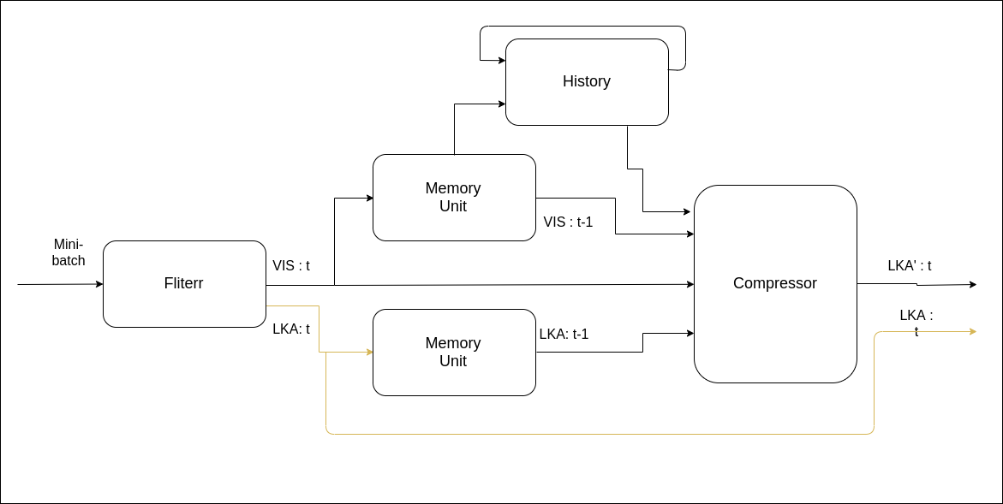
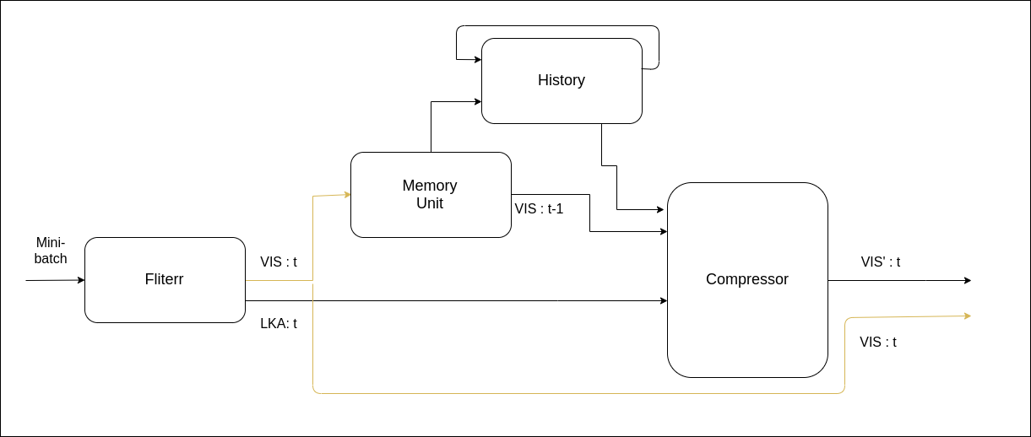
VIS predictor and LKA predictor respectively

Components
Filter: Responsible for extracting the VIS and LKA frames from many batches.
Memory unit: act as time delay unit
History: Convolution layer that stacks itself with the current input frame and produce an output of its size again (represent the full sequence of frames in shape of one frame).
Compressor: Feature extractor that consists of 2 Linear layers that increase the features to 1024 and compress it back to dimension of single lka or vis frame.

VIS Predictor
The compressor takes as input:
- Previous VIS frame VIS(t-1)
- VIS History
- Current LKA frame
It outputs its expectation (VIS’) for the vis of timestamp(t).

LKA Predictor
A very similar construction where the compressor takes as input:
- Previous VIS frame VIS(t-1)
- VIS History
- Current VIS frame VIS(t)
- Previous LKA frame LKA(t-1)
It outputs its expectation (LKA’) for the vis of timestamp(t).

Results
Similar Settings are used as for previous models.
For evaluation we suggest the usage of 2 loss functions:
- Binary Cross Entropy BCE
- Structural Similarity
Note anomaly occur at batch 23
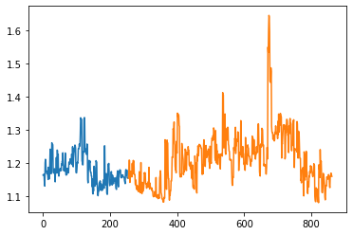
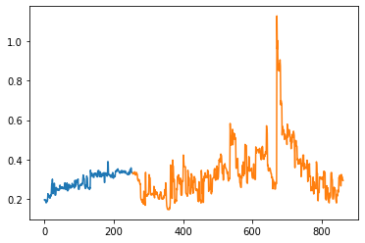
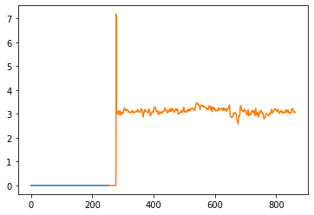
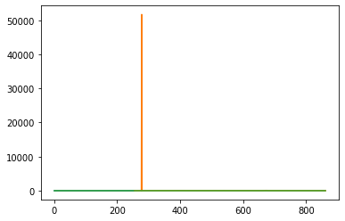

X-axis represents batch number, y-axis is the loss obtained,images represent from left VIS predictor with SSIM and BCE , LKA predictor with SSIM and BCE respectively.

 | BCE |  | SSIM
Models | Batch number | Difference | Batch number | Difference
VIS Predictor | 416 - 430 | 393 | 416 - 426 | 393
LKA Predictor | 24 | 0 | 24 | 0

In the Table, Batch number means the batches that the model produced a trigger for anomaly, Difference is the number of batches passed since the actual anomaly occurred.
As shown the LKA Predictor provides an instantaneous trigger which shows the high responsiveness of the model, while on the other hand VIS predictor provides a longer trigger in terms of number of mini-batches which makes the trigger more recognizable.
Both models could be integrated together to provide both early and late alarms for the car but with extra overhead in terms of memory and computation.

Appendix

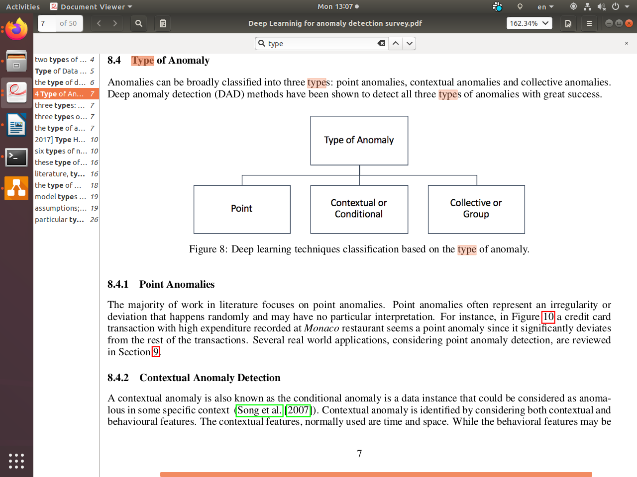
Anomaly types:
Point Anomaly: often represent an irregularity or
deviation that happens randomly and may have no particular interpretation.

Contextual Anomaly: also known as the conditional anomaly is a data instance that could be considered as anomalous in some specific context (Song et al. [2007]).

Collective or Group Anomaly: wherein each of the individual points in isolation appears as normal data instances while observed in a group exhibit unusual characteristics.

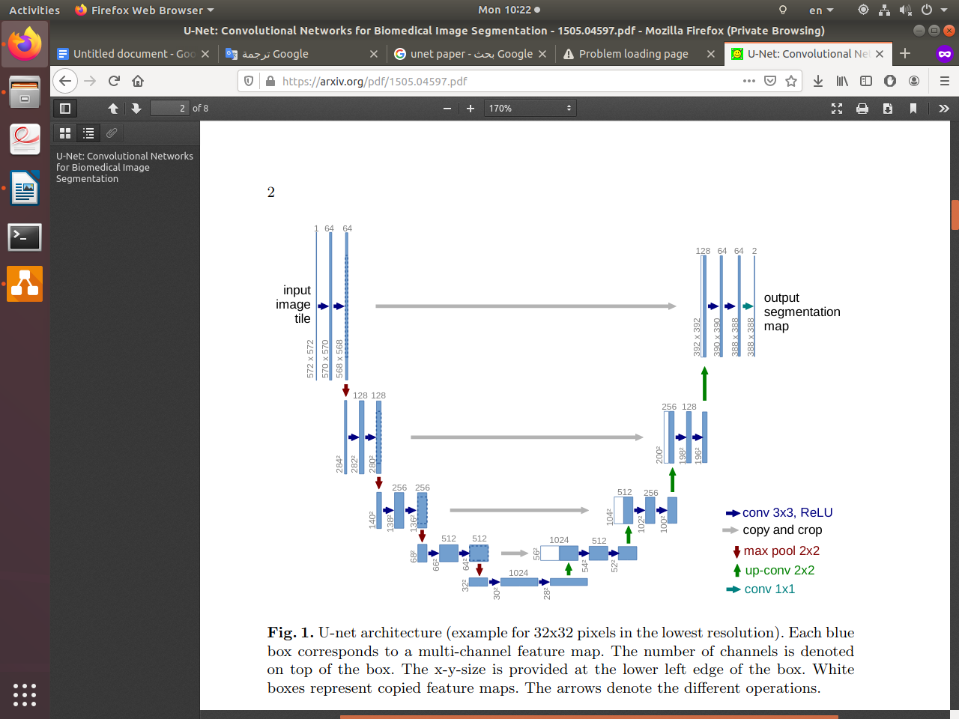
U-Net (unet paper)
It consists of a contracting path (left side) and an expansive path (right side). The contracting path follows the typical architecture of a convolutional network. It consists of the repeated application of two 3x3 convolutions (unpadded convolutions), each followed by a rectified linear unit (ReLU) and a 2x2 max pooling operation with stride 2for downsampling. At each downsampling step we double the number of feature channels. Every step in the expansive path consists of an upsampling of the feature map followed by a 2x2 convolution (“up-convolution”) that halves the number of feature channels, a concatenation with the correspondingly cropped feature map from the contracting path, and two 3x3 convolutions, each fol-lowed by a ReLU. The cropping is necessary due to the loss of border pixels in every convolution. At the final layer a 1x1 convolution is used to map each 64-component feature vector to the desired number of classes. In total the network has 23 convolutional layers.

Implementation used is from https://pytorch.org/hub/mateuszbuda_brain-segmentation-pytorch_unet/

Transformer (attention is all what you need)
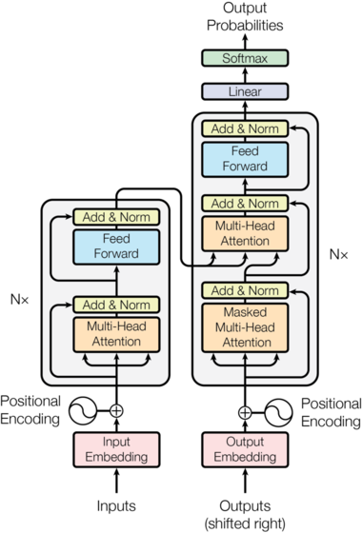
The Transformer follows this overall architecture using stacked self-attention and point-wise, fully connected layers for both the encoder and decoder, shown in the left and right halves of Figure 1,respectively.
We use only the right block of the architecture (decoder component)
Decoder: The decoder is also composed of a stack of N = 2 identical layers.Each layer has two
sub-layers. The first is a multi-head self-attention mechanism, and the second is a simple, position-
wise fully connected feed-forward network. In addition to the two sub-layers, the decoder inserts a third sub-layer, which performs multi-head
attention over the output of the encoder stack. we employ residual connections around each of the sub-layers, followed by layer normalization. We also modify the self-attention sub-layer in the decoder stack to prevent positions from attending to subsequent positions. This masking, combined with the fact that the output embeddings are offset by one position, ensures that the predictions for position i can depend only on the known outputs at positions less than i.

Our implementation use
https://github.com/jadore801120/attention-is-all-you-need-pytorch

